MISS CONTESTANT APPLICATION
If you are interested in earning college scholarships, furthering your communication skills and want to champion a charitable organization or cause you are passionate about, and share your talent, then please join us!

Full Name: Shirt Size:

Date of Birth: Current Age:

Mailing address:

Email:

Cell: Hometown:

Talent:

School:

Current YEAR in School (if applicable):

Expected Year of Graduation (if applicable):

Full Time Employer & Position (if applicable):

Parents’ or Guardians Names/Relationship:

Parent Cell Number:

Parent Email Address:

Instagram Handle:

Facebook Page Name:

TikTok:

How did you hear about us?

Please Note: There is a participation fee that varies based upon sign up time.

Early Sign Up Participation Fee: $75 (Deadline 2/15/23)
Regular Sign-Up Participation Fee: $100 (Deadline 3/20/23)

Fees offset the cost of hosting the event, meals for contestants, supporting the PTPA and Youth Arts through the venue rental, and scholarships and prizes for participants.
MGHSO is a 501c3 non-profit organization. Fees are a donation and tax deductible.

The Miss Competition is a Development Mentoring Program and Fundraiser to support the Miss Greater Hazleton Scholarship Organization (MGHSO). Participants and Winners are encouraged to participate and compete in other scholarship, pageant and talent programs while representing the MGHSO. The MGHSO does not have a non-compete clause. We encourage you to volunteer your time and make a difference within the community and S.E.R.V.E.

Important Volunteer Service Dates: Hazle Township Fall Festival & Trail of Treats on Saturday & Sunday, October 21 & 22, 2023, in Hazle Township Community Park.

“Volunteers working to educate and inspire our next generation of volunteers…”

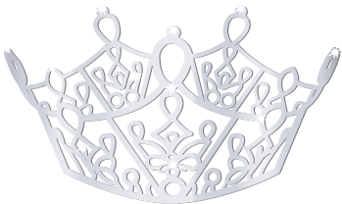

Are you interested in holding a Title within the Organization regardless of your placement in the program and/or advancing to a state program? The state program has at large contestant opportunities, and we will offer the opportunity to extend mentoring to those individuals.

