Name:
PICTURE Instructions:
Delete this text box.
Replace Picture with your own headshot.

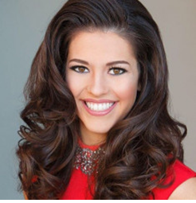

Title: CONTESTANT

Instagram Handle: @

Age:

Platform Title:

Talent:

Education:

Professional Objective:

Honors & Achievements:

Leadership Positions:

Employment Experience:

Special Skills & Activities:
What can you do during your Tenure of Service as a Titleholder to impact your community? Answer

What has been your involvement with your platform, including time commitment, strategic planning and ways your ingenuity and resourcefulness have been demonstrated? Answer

What inspired you to first become involved in your platform? Answer

If awarded the job as a Miss Greater Hazleton Titleholder, how would you mobilize and market your platform locally and statewide? Answer

How would you utilize social media in order to further the position and job of a Miss Greater Hazleton Titleholder/Representative? Answer

