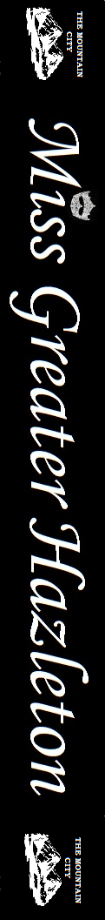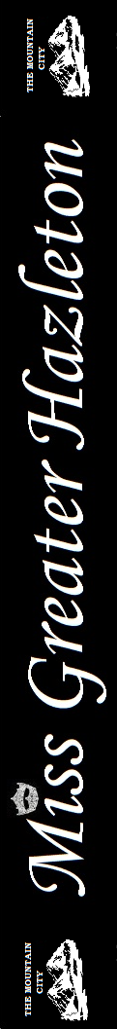

Proudly Presents



**Miss Greater Hazleton 2015**

**Kate Marhelko**

Scoliosis: When Life Throws You A Curve

Sponsored *&* Supported by Greater Hazleton Area Businesses

