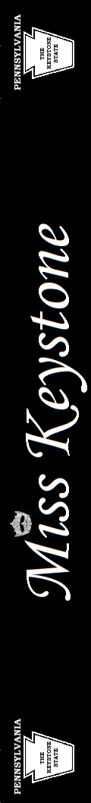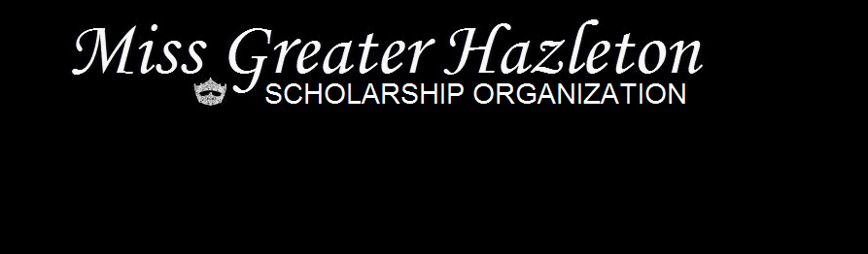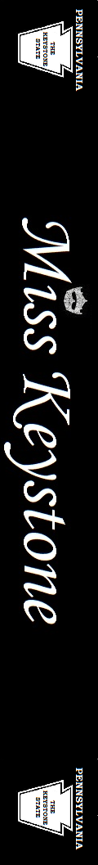

Proudly Presents

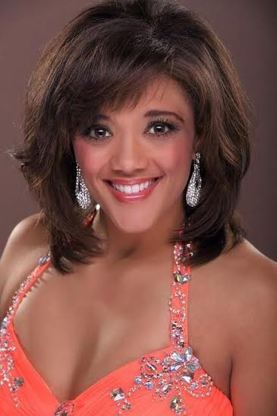

**Miss Keystone 2015**

**Alyssa Marsh**

Breaking the Glass: Women Empowerment

Sponsored *&* Supported by Greater Hazleton Area Businesses

