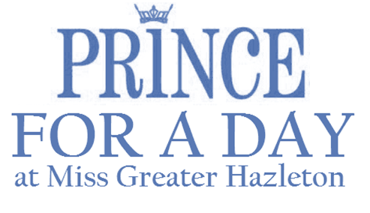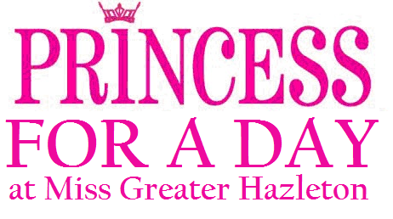

2017 APPLICATION FORM
Please complete and mail immediately to hold your spot! Spots are limited.

Full Name (PRINT AS IT WILL APPEAR IN PROGRAM)

Age
Date of Birth Grade Level (2017)

Parent or Guardian Name(s) attending with child

Home Address

City, State & Zip
Phone #

Email Addresses (PARENT OR GUARDIAN)

Special Needs, Allergies or Medical concerns

Past Dance or On-Stage Experience (will not limit participation)

Emergency Contact Phone Number

A Princess for a Day Participant is to wear their prettiest dress (think Christmas/Easter/Holiday attire!).
A Prince for a Day Participant is to wear a dress shirt/polo shirt and pants or a suit (think Christmas/Easter/Holiday attire!).

Participation Includes: 1 Child Admission, 1 Adult Admission for Accompanying Parent/Guardian, a Reserved Seating Section, a Special Gift, Time with MGHSO Titleholders & Contestants, & Participation in the Miss Greater Hazleton Scholarship Program’s Opening Number.

Participants are to arrive by 3PM at MMI Preparatory School on Sunday, November 19, 2017. Parents/Guardians are asked to stay with their child. I understand the cost for this program is a fundraiser for the Miss Greater Hazleton Scholarship Organization and is non-refundable. By Allowing my child to participate in this program, I grant permission for the Miss Greater Hazleton Scholarship Organization to utilize photographs and videos of my child for advertising and publicity.

Parent or Guardian Signature Date

Submit Payment Through Paypal & Mail Application OR Mail Application with a $35 Check/Money Order to:

Miss Greater Hazleton Scholarship Organization, c/o Sherri Homanko 349 West 30th Street, Hazle Township, PA 18202
Checks should be made to Miss Greater Hazleton Scholarship Organization: Memo Line- Princess/Prince for a Day Fundraiser.
**Participation can also be paid through Paypal and a scanned copy of the application can be submitted by email.

If paying through Paypal and emailing a copy of the application, please mail original signed application to address listed above.

If you have any questions, comments, or concerns, please contact missgreaterhazletonpageant@gmail.com

