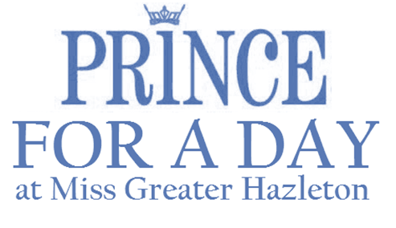
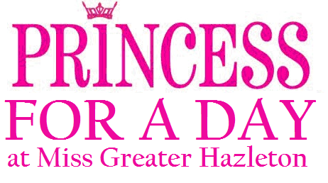

2018 APPLICATION FORM
Please complete and e-mail immediately to hold your spot! Spots are limited.

Full Name (PRINT AS IT WILL APPEAR IN PROGRAM)

Age
Date of Birth Grade Level if applicable (2018)

Parent or Guardian Name(s) attending with child

Home Address

City, State & Zip
Phone #

Email Addresses (PARENT OR GUARDIAN)

Special Needs, Allergies or Medical concerns

Past Dance or On-Stage Experience (will not limit participation)

Emergency Contact Phone Number

A Princess for a Day Participant is to wear their prettiest dress (think Christmas/Easter/Holiday attire!).
A Prince for a Day Participant is to wear a dress shirt/polo shirt and pants or a suit (think Christmas/Easter/Holiday attire!).

Participation Includes: 1 Free Princess or Prince Admission, a Reserved Seating Section, a Special Gift, Time with MGHSO Titleholders & Contestants, & Participation in the Miss Greater Hazleton Scholarship Program’s Opening Number.
Royal Escorts (Adults/Guardians) receive a discount to attend scholarship program for $15.

Deadline: Sunday, November 11th, 2018 to be included in the Program Book.

Participants are to arrive by 2:30PM at MMI Preparatory School on Sunday, November 18, 2018. Parents/Guardians are asked to stay with their child. I understand the cost for this program is a fundraiser for the Miss Greater Hazleton Scholarship Organization and is non-refundable. By Allowing my child to participate in this program, I grant permission for the Miss Greater Hazleton Scholarship Organization to utilize photographs and videos of my child for advertising and publicity.

Parent or Guardian Signature Date

Submit Payment for Royal Escort Tickets Through Paypal or Mail Check with Application to Address below.

Miss Greater Hazleton Scholarship Organization, c/o Sherri Homanko 349 West 30th Street, Hazle Township, PA 18202
Checks should be made to Miss Greater Hazleton Scholarship Organization: Memo Line- Princess/Prince for a Day Fundraiser.
**Participation can also be paid through Paypal and a scanned copy of the application can be submitted by email.

If paying through Paypal and emailing a copy of the application, please mail original signed application to address listed above.

If you have any questions, comments, or concerns, please contact missgreaterhazletonpageant@gmail.com

